## Persistence – Exam Preparation Question

**General part**

* Describe how we have handled persistence in the last three semesters. The considerations should include all relevant layers. File IO, Relational Databases, the browsers local storage and cookies.
* Discuss how we usually have queried a relational database
* Explain the Pros & Cons in using an Object Relational Mapping Framework
* Elaborate on some of the problems a ORM tries to solve
* Discuss the methods we can use to query a JPA design and compare with what you explained above

**Practical part**

*This exercise requires a MySQL database. Set up the database as described below:*

* Create a new MySQL database ***jpqlDemo***, either from within Netbeans or using MySQL Workbench.
* Create a new plain java project; ***jpqlDemo*** with NetBeans.

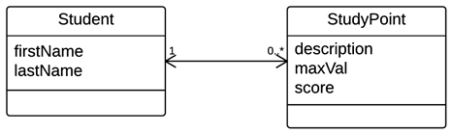In this project create a folder **scripts** and copy the file *studypoints.sql*  into this folder and execute the script on the jpqlDemo database.

This script creates two tables which simulates a (very very) simple study point system with students and their study points as sketched in this figure. The script does the following:

* Create the two tables.
* Insert two students and assign study points for a week to each of them (initially, all with a score = 0)
* Updates the study point scores for each student to simulate study points given for a week

A) Use the NetBeans Wizard "New Entity Classes from Database" to create a pair of matching Entity Classes.

B Investigate the generated Entity classes and observe the NamedQueries generated by the Wizard.

C) Create the Dynamic Queries (or when possible, use one of the named Queries generated by the wizard) to solve the following problems:

1. Find all Students in the system
2. Find all Students in the System with the first Name jan
3. Find all Students in the system with the last name Olsen
4. Find the total sum of study point scores, for a student given the student id.
5. Find the total sum of studypoint scores, given to all students.
6. Find those students that has the greatest total of studypoint scores
7. Find those students that has the lowest total of studypoint scores

D) Create the following methods to insert new data into the system

1. Create a method to create new Students and test the method
2. Add a method to the Student class addStudyPoint(..) and test the method